**MongoDB Assignment – 3**

* **Mongo DB Exercises - With the Restaurants Data Set**

* Write a MongoDB query to display all the documents in the collection restaurants.
* db.addresses.find().pretty()

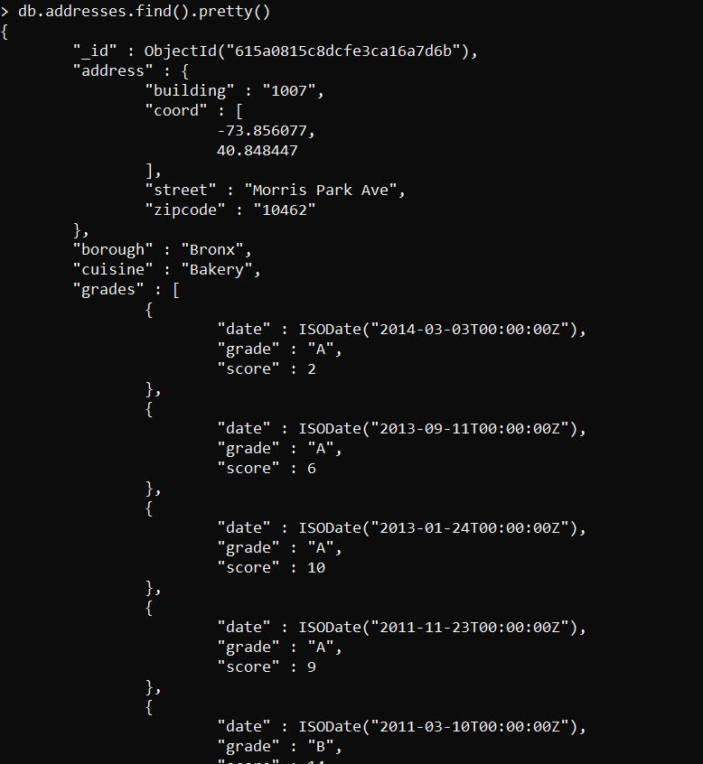

* Write a MongoDB query to display the fields restaurant_id, name, borough and cuisine for all the documents in the collection restaurant.
* db.addresses.aggregate([{$project:{restaurant_id:1,name:1,borough:1,cuisine:1}}]).pretty()

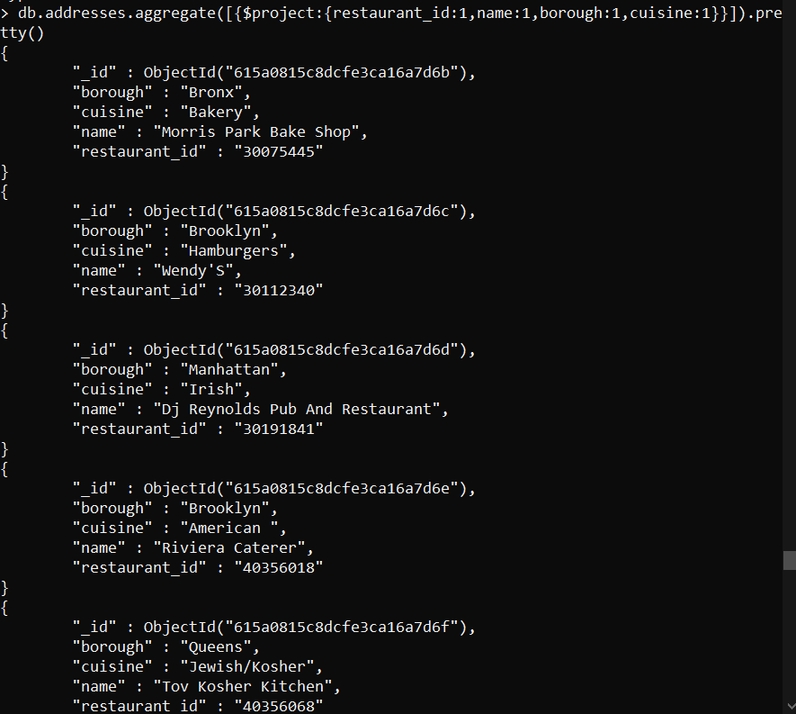

* Write a MongoDB query to display the fields restaurant_id, name, borough and cuisine, but exclude the field _id for all the documents in the collection restaurant.
* db.addresses.aggregate([{$project:{restaurant_id:1,name:1,borough:1,cuisine:1,_id:0}}]).pretty()

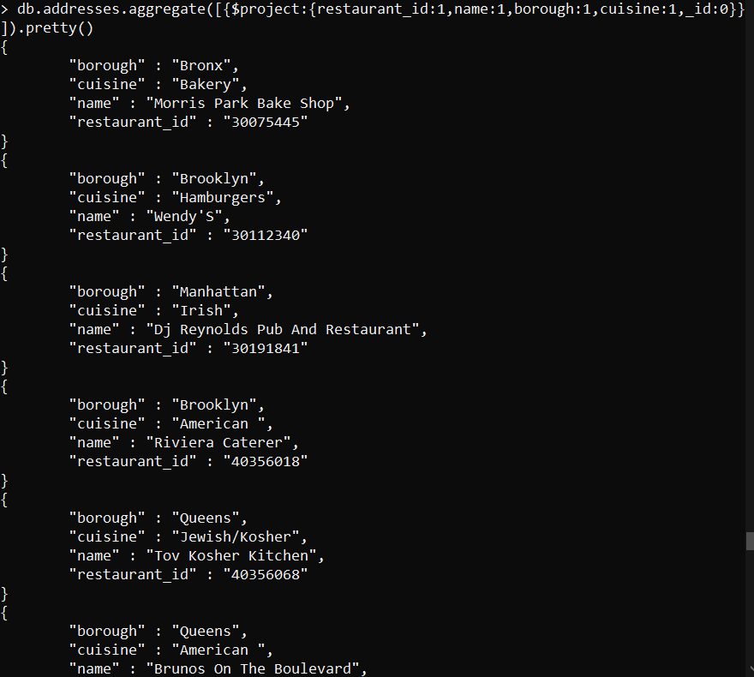

* Write a MongoDB query to display the fields restaurant_id, name, borough and zip code, but exclude the field _id for all the documents in the collection restaurant.
* db.addresses.aggregate([{$project:{restaurant_id:1,name:1,borough:1,"address.zipcode":1,_id:0}}]).pretty()

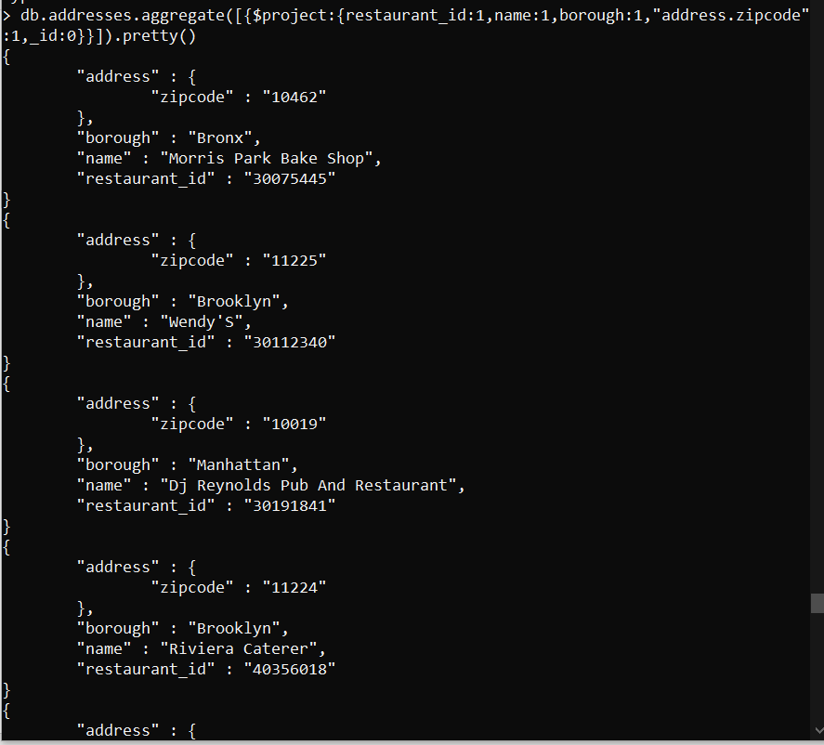

* Write a MongoDB query to display the first 5 restaurant which is in the borough Bronx.
* db.addresses.aggregate([{$match:{borough:"Bronx"}},{$sort:{_id:1}},{$limit:5}])

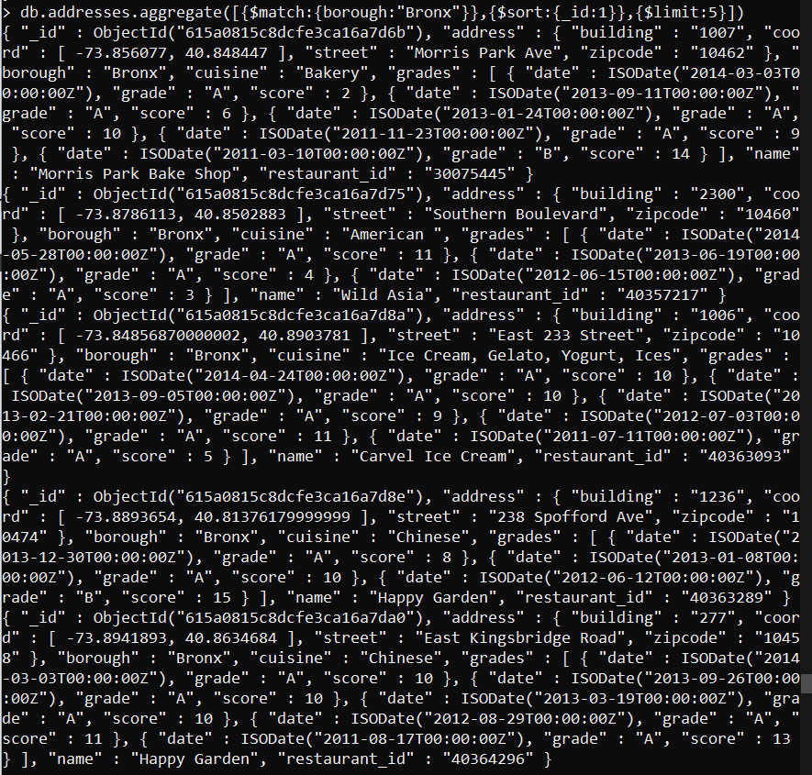

* Write a MongoDB query to display all the restaurant which is in the borough Bronx.
* db.addresses.aggregate([{$match:{borough:"Bronx"}}]).pretty()

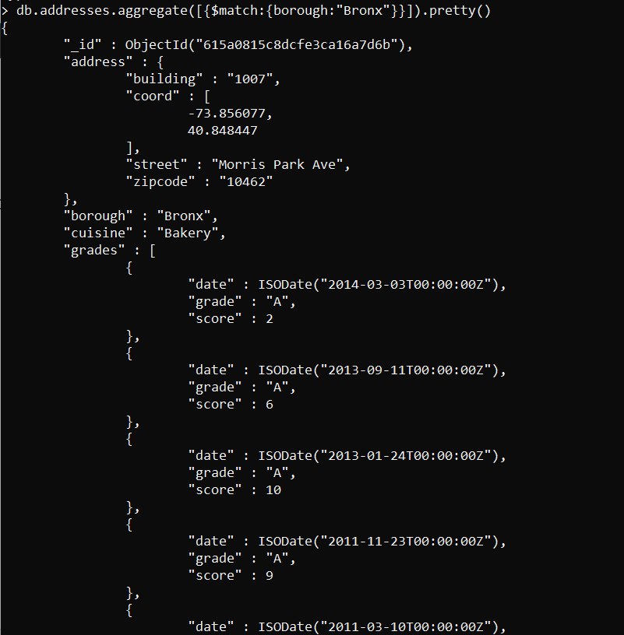

* Write a MongoDB query to display the next 5 restaurants after skipping first 5 which are in the borough Bronx.
* db.addresses.aggregate([{$match:{borough:"Bronx"}},{$sort:{_id:1}},{$skip:5},{$limit:5}]).pretty()

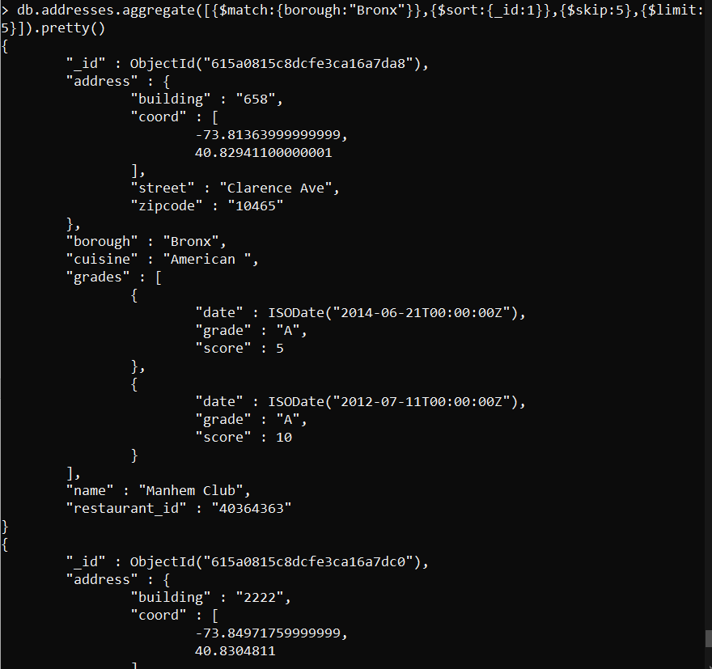

* Write a MongoDB query to find the restaurants who achieved a score more than 90.
* db.addresses.find({"grades.score":{$gt:90}}).pretty()

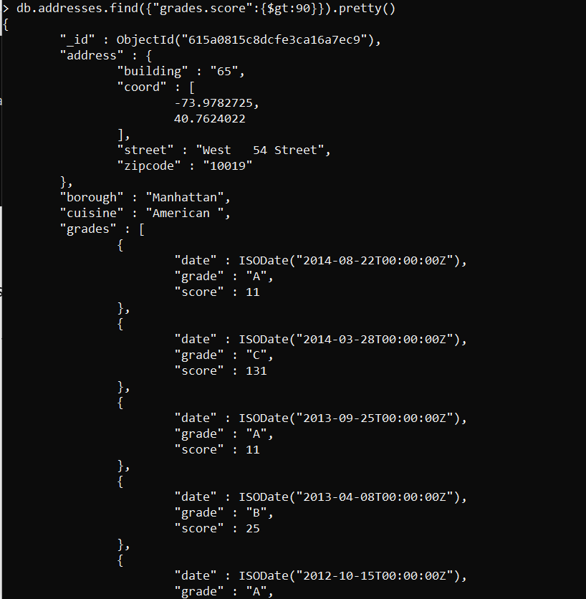

* Write a MongoDB query to find the restaurants that achieved a score, more than 80 but less than 100.
* db.addresses.find({"grades.score":{$gt:80,$lt:100}}).pretty()

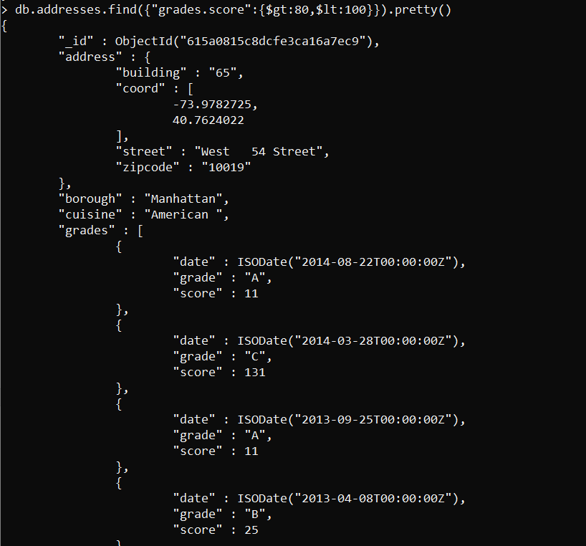

* Write a MongoDB query to find the restaurants which locate in latitude value less than -95.754168.
* db.addresses.find({"address.coord":{$lt:-95.754168}}).pretty()

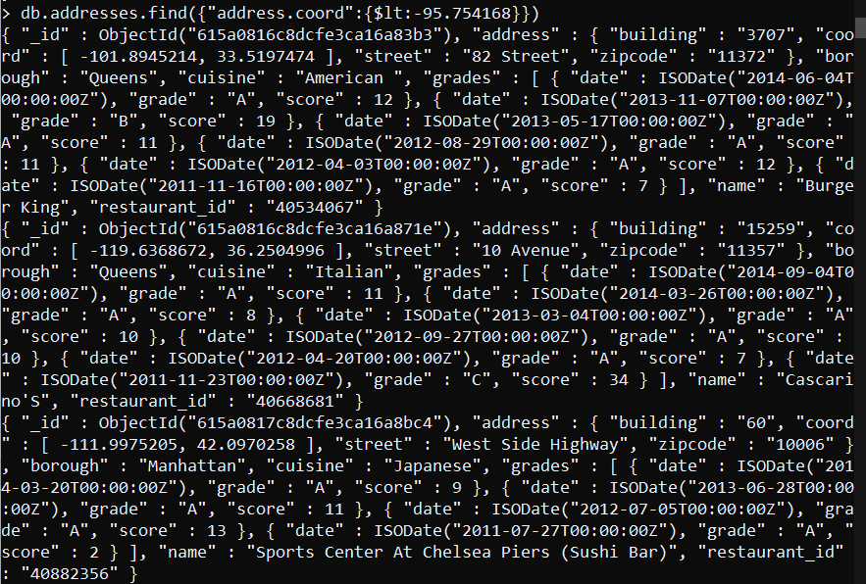

* Write a MongoDB query to find the restaurants that do not prepare any cuisine of 'American' and their grade score more than 70 and latitude less than -65.754168.
* db.addresses.find({$and:[{cuisine:{$ne:"American"}},{"grades.score":{$gt:70}},{"address.coord":{$lt:-65.754168}}]}).pretty()

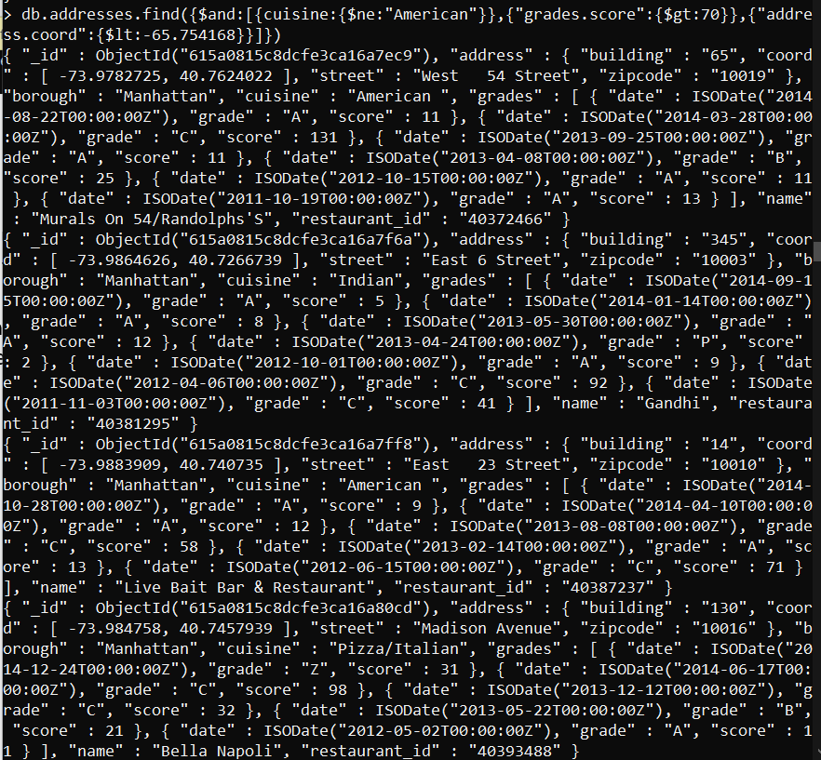

* Write a MongoDB query to find the restaurants which do not prepare any cuisine of 'American' and achieved a score more than 70 and located in the longitude less than -65.754168.
* db.addresses.find({$and:[{cuisine:{$ne:"American"}},{"grades.score":{$gt:70}},{"address.coord":{$lt:-65.754168}}]}).pretty()



* Write a MongoDB query to find the restaurants which do not prepare any cuisine of 'American ' and achieved a grade point 'A' not belongs to the borough Brooklyn. The document must be displayed according to the cuisine in descending order.
* db.addresses.find({$and:[{cuisine:{$ne:"American "}},{"grades.grade":"A"},{borough:{$ne:"Brooklyn"}}]}).sort({cuisine:-1}).pretty()

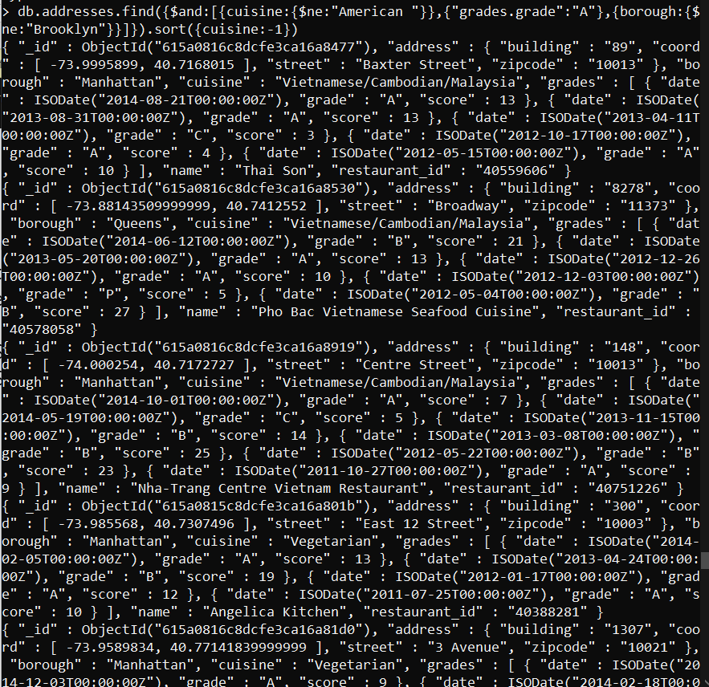

* Write a MongoDB query to find the restaurant Id, name, borough and cuisine for those restaurants which contain 'Wil' as first three letters for its name.
* db.addresses.find({name: /^Wil/},{"restaurant_id" : 1,"name":1,"borough":1,"cuisine" :1})
* Write a MongoDB query to find the restaurant Id, name, borough and cuisine for those restaurants which contain 'ces' as last three letters for its name.
* db.addresses.find({name: /ces$/},{"restaurant_id" : 1,"name":1,"borough":1,"cuisine" :1})
* Write a MongoDB query to find the restaurant Id, name, borough and cuisine for those restaurants which contain 'Reg' as three letters somewhere in its name.
* db.addresses.find({name: /.*Reg.*/},{"restaurant_id" : 1,"name":1,"borough":1,"cuisine" :1})

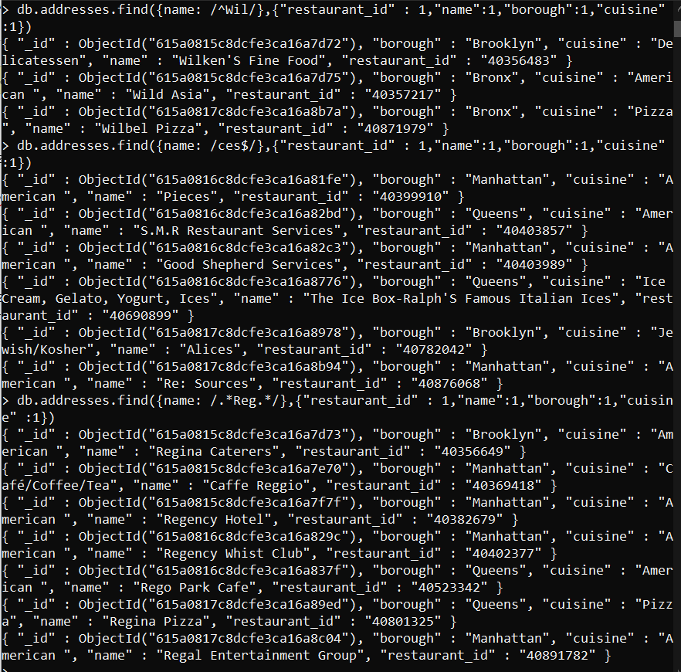

* Write a MongoDB query to find the restaurants which belong to the borough Bronx and prepared either American or Chinese dish.
* db.addresses.find({borough: "Bronx", cuisine: {$in: ["American ","Chinese"]}}, {_id:0, restaurant_id:1, name:1, borough:1, cuisine:1})

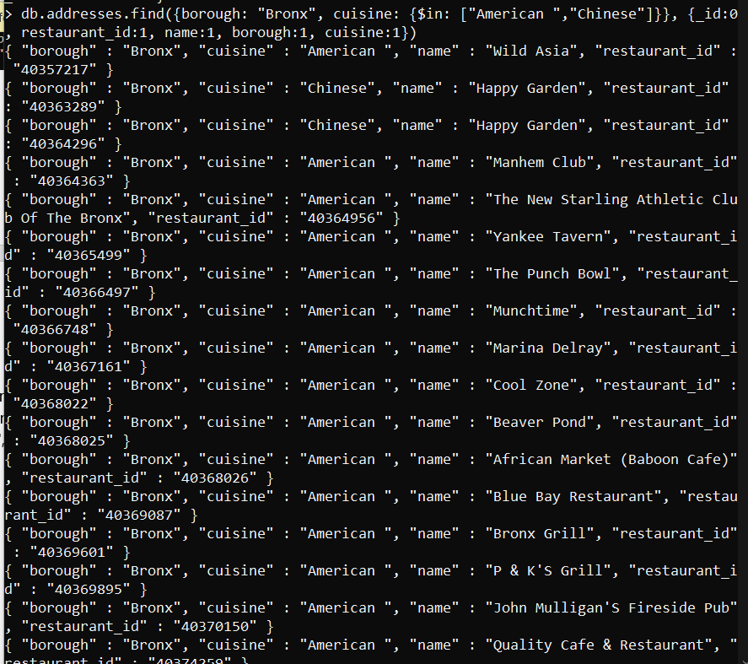

* Write a MongoDB query to find the restaurant Id, name, borough and cuisine for those restaurants which belong to the borough Staten Island or Queens or Bronxor Brooklyn.
* db.addresses.find({$or: [{"borough": "Staten Island"}, {"borough": "Bronxor Brooklyn"}, {"borough": "Queens"}]}, {_id:0, restaurant_id:1, name:1, borough:1, cuisine:1})

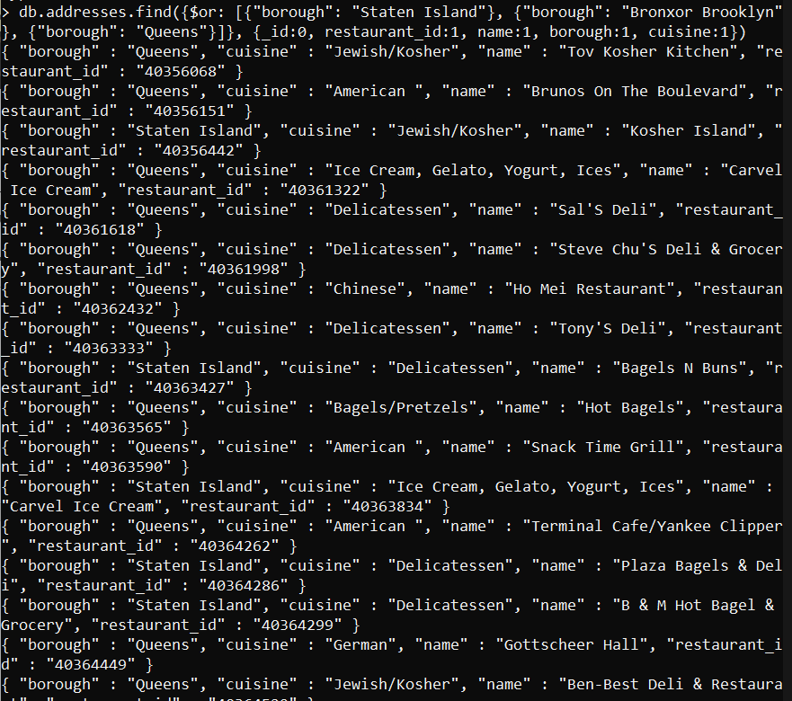

* Write a MongoDB query to find the restaurant Id, name, borough and cuisine for those restaurants which are not belonging to the borough Staten Island or Queens or Bronxor Brooklyn.
* db.addresses.find( {borough: {$nin: ["Staten Island","Queens","Bronx","Brooklyn"]}} , {_id:0, restaurant_id:1, name:1, borough:1, cuisine:1})

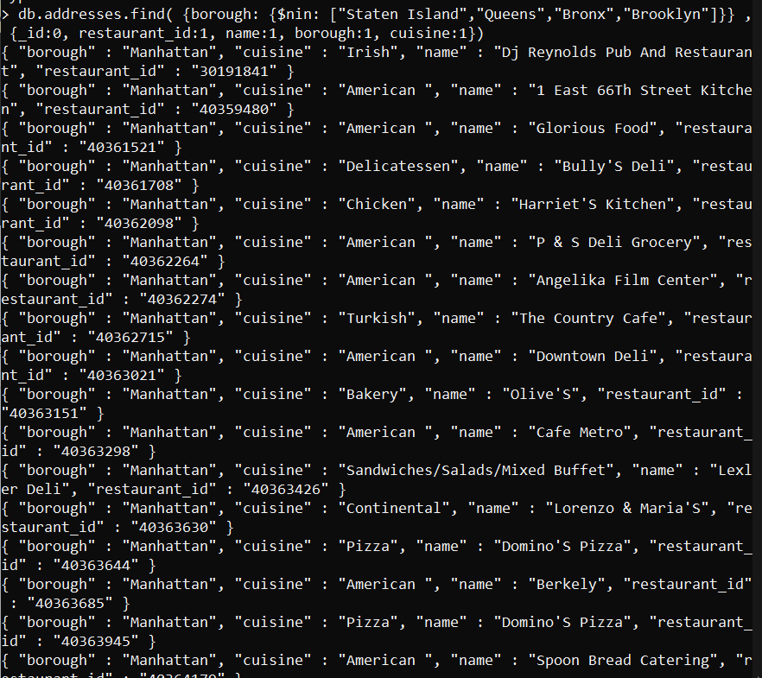

* Write a MongoDB query to find the restaurant Id, name, borough and cuisine for those restaurants which achieved a score which is not more than 10.
* db.addresses.find({"grades.score": {$lte: 10}}, {_id:0, restaurant_id:1, name:1, borough:1, cuisine:1})

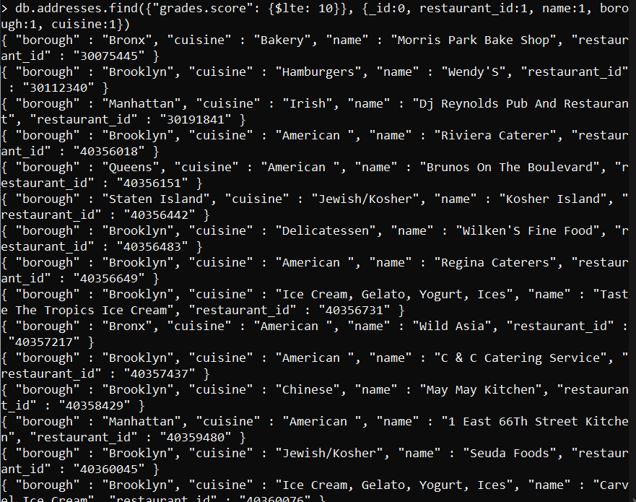

* Write a MongoDB query to find the restaurant Id, name, borough and cuisine for those restaurants which prepared dish except 'American' and 'Chinees' or restaurant's name begins with letter 'Wil'.
* db.addresses.find({$nor: [{cuisine: {$in: ["American ","Chinese"]}},{name: /^Wil.*/}]},{_id:0, restaurant_id:1, name:1, borough:1, cuisine:1})

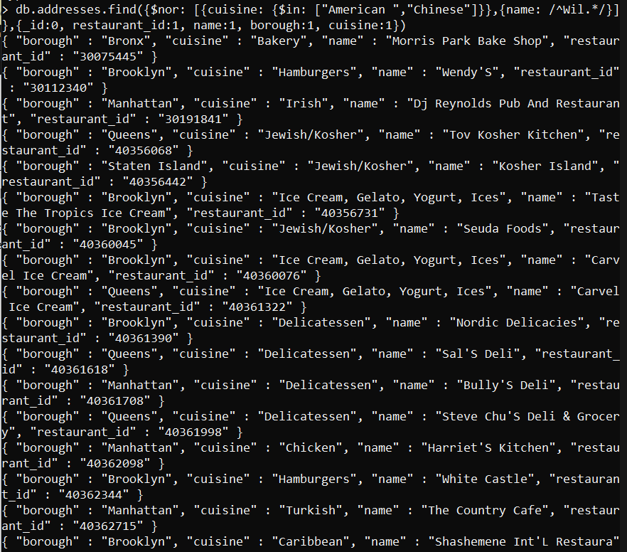

* Write a MongoDB query to find the restaurant Id, name, and grades for those restaurants which achieved a grade of "A" and scored 11 on an ISODate "2014-08-11T00:00:00Z" among many of survey dates..
* db.addresses.find({"grades" : {$elemMatch: {"date": ISODate("2014-08-11T00:00:00Z"), "grade":"A", "score":11}}}, {_id:0, restaurant_id:1, name:1, grades:1}).pretty()

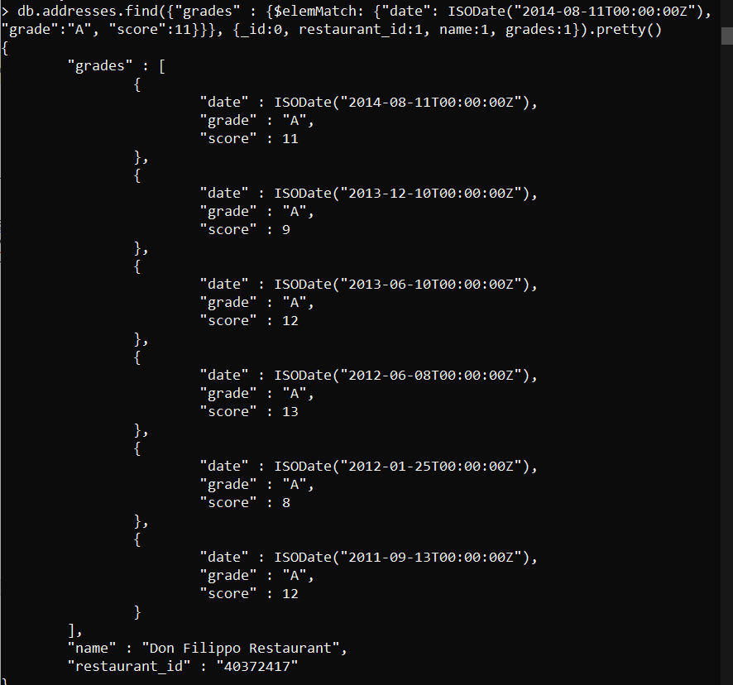

* Write a MongoDB query to find the restaurant Id, name and grades for those restaurants where the 2nd element of grades array contains a grade of "A" and score 9 on an ISODate "2014-08-11T00:00:00Z"
* db.addresses.find({$and: [{"grades.1.grade":"A"}, {"grades.1.score": 9}, {"grades.1.date": ISODate("2014-08-11T00:00:00Z")}]},{_id:0, restaurant_id:1, name:1, grades:1}).pretty()

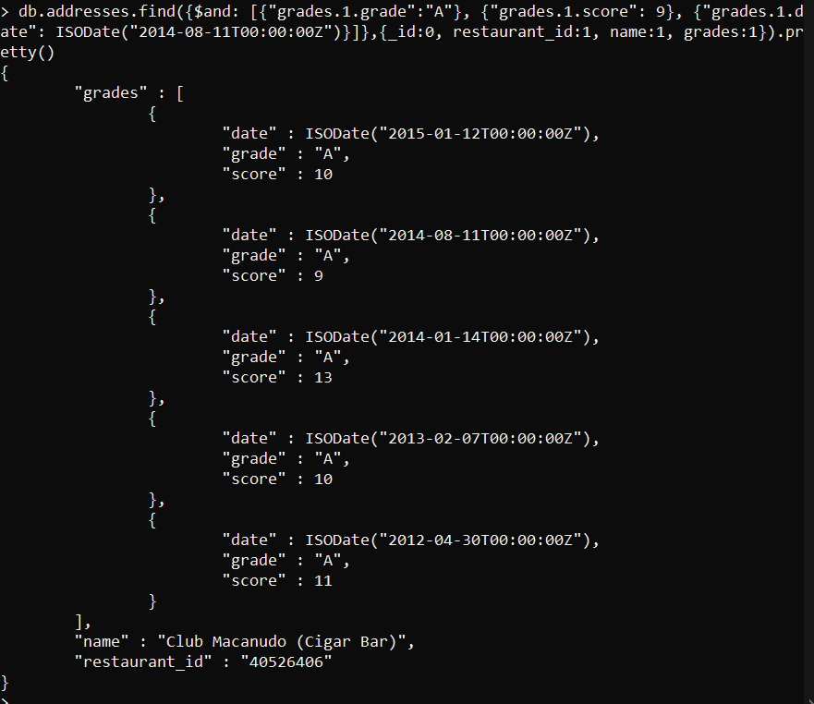

* Write a MongoDB query to find the restaurant Id, name, address and geographical location for those restaurants where 2nd element of coord array contains a value which is more than 42 and upto 52..
* db.addresses.find({$and : [{"address.coord.1": {$gt : 42}},{"address.coord.1": {$lte : 52}}]}, {_id:0, restaurant_id:1, name:1, address:1})

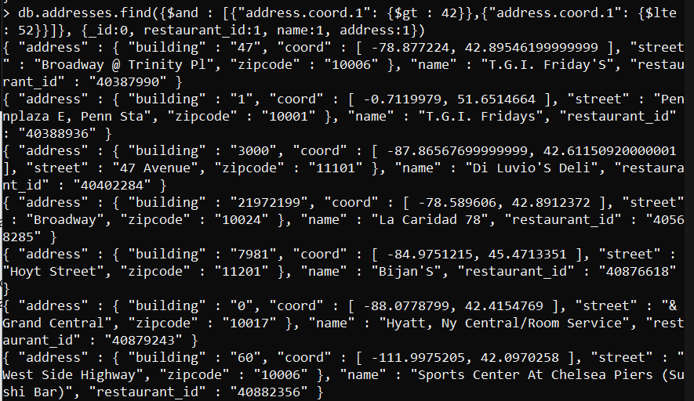

* Write a MongoDB query to arrange the name of the restaurants in ascending order along with all the columns.
* db.addresses.find({},{_id:0, name:1}).sort( {name: 1})

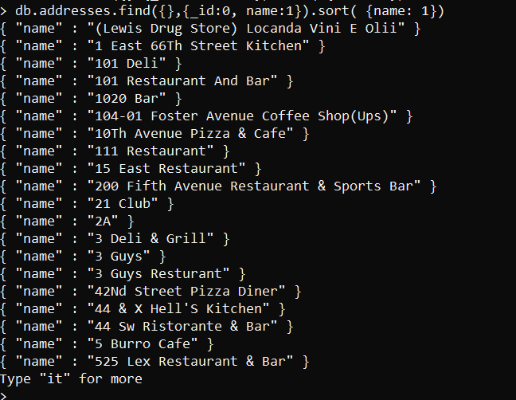

* Write a MongoDB query to arrange the name of the restaurants in descending along with all the columns.
* db.addresses.find({},{_id:0, name:1}).sort( {name: -1})

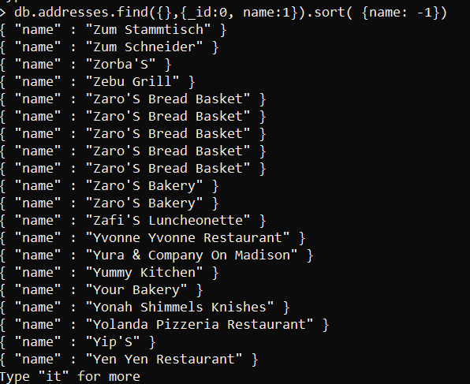

* Write a MongoDB query to arranged the name of the cuisine in ascending order and for that same cuisine borough should be in descending order.
* db.addresses.find({}, {_id:0, cuisine:1, borough:1}).sort({cuisine: 1, borough: -1})

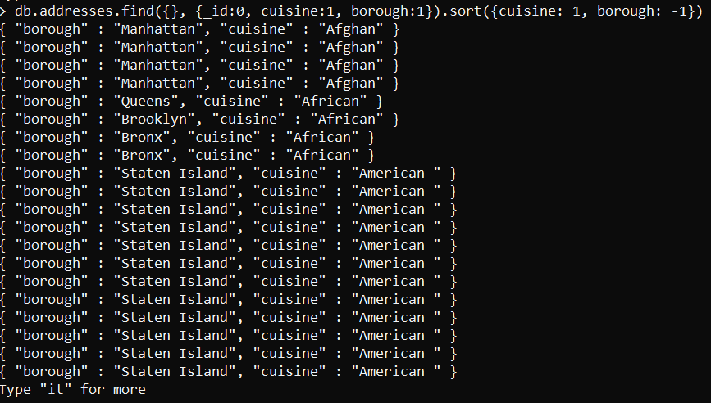

* Write a MongoDB query to know whether all the addresses contains the street or not.
* db.addresses.find({"address.street": {$regex: /Street/}}).pretty()

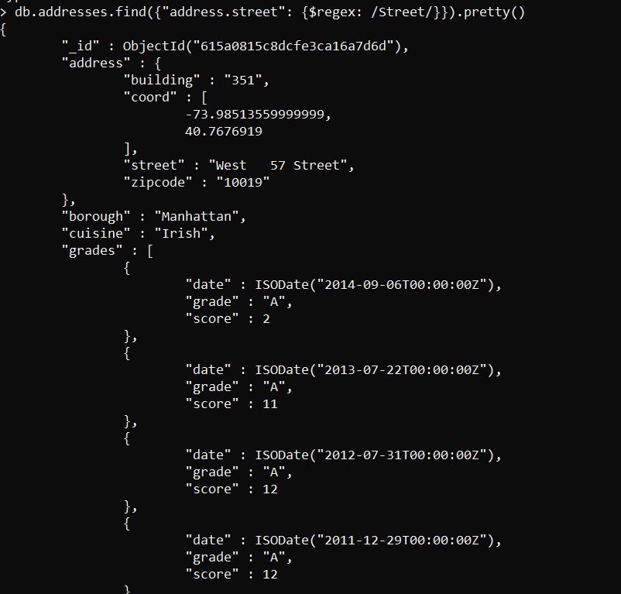

* Write a MongoDB query which will select all documents in the restaurants collection where the coord field value is Double.
* db.addresses.find({"address.coord": {$type: "double"}}, {_id:0, address:1})

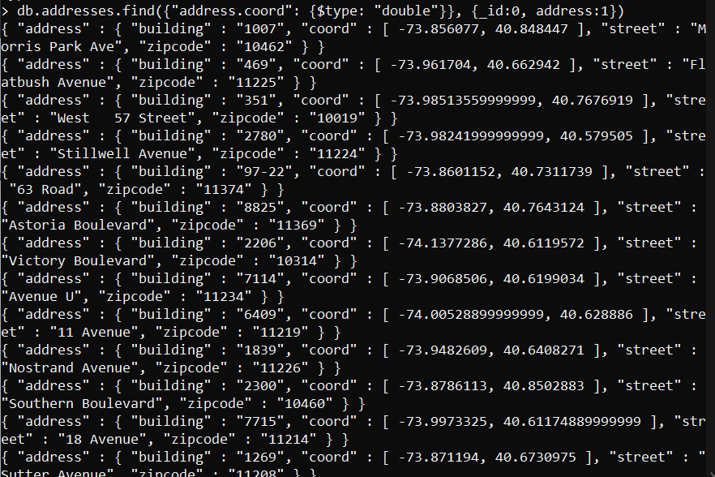

* Write a MongoDB query which will select the restaurant Id, name and grades for those restaurants which returns 0 as a remainder after dividing the score by 7.
* db.addresses.find({"grades": {$elemMatch: {"score": {$mod: [7,0]}}}},{_id:0, restaurant_id:1, name:1, grades:1})

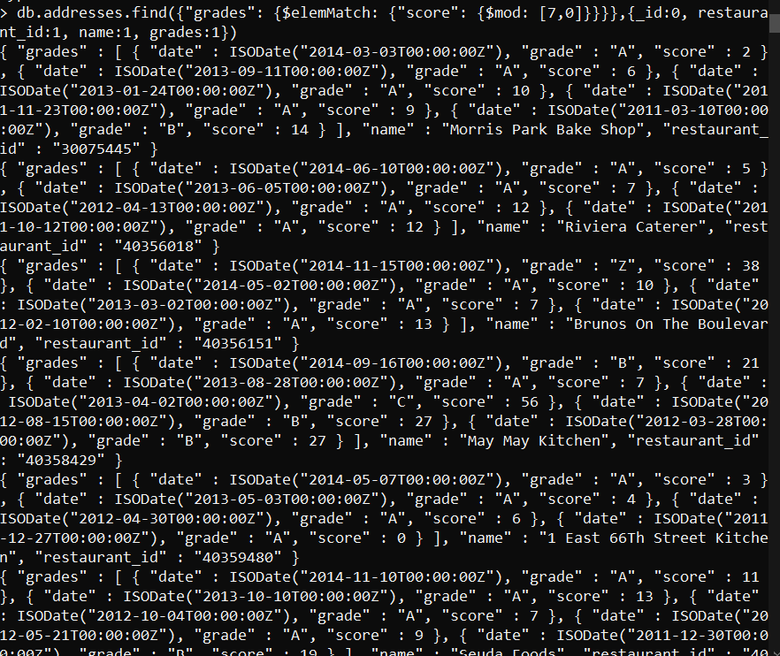

1. Write a MongoDB query to find the restaurant name, borough, longitude and attitude and cuisine for those restaurants which contains 'mon' as three letters somewhere in its name.

* db.addresses.find({name: {$regex: /mon/}},{_id:0, name:1, borough:1, "address.coord":1, cuisine:1})

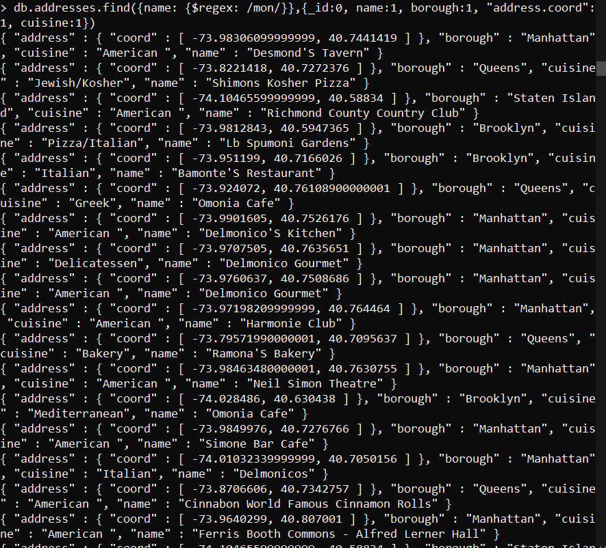

1. Write a MongoDB query to find the restaurant name, borough, longitude and latitude and cuisine for those restaurants which contain 'Mad' as first three letters of its name.

* db.addresses.find({name: {$regex: /^Mad.*/}},{_id:0, name:1, borough:1, "address.coord":1, cuisine:1})

